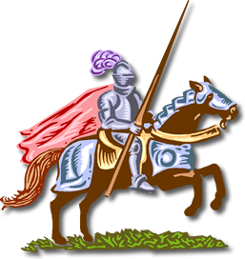
Romantic Hero
Romance: This term originate in the Middle Ages. It was first used to describe stories believed to be based upon Latin originals (stories told by the Romans). However, it came to be used in Europe and England for stories about knightly exploits.

Other Characteristics:
- Medieval romance usually idealizes chivalry
- Medieval romance Idealizes the hero-knight and his noble deeds
- An important element of the medieval romance is the knight's love for his lady.
- The settings of medieval romance tend to be imaginary and vague.
- Medieval romance derives mystery and suspense from supernatural elements.
- Medieval romance uses concealed or disguised identity.
Characteristics of the Romantic Hero: The romantic hero is the classic knight in shining armor. He tries to battle the dragon or the foe in order to save the maiden or find the treasure. He is a classic literary archetype that follows Campbell’s 12 Step Hero Cycle perfectly.
- Birth of a great hero is shrouded in mystery
- He is reared away from his true home in ignorance of his real parents.
- For a time his true identity is unknown
- After meeting an extraordinary challenge, he claims his right
- His triumph benefits his nation or group.
Chivalry : the code of conduct of the medieval knight
According to the code of chivalry, a knight was to be the perfect example of virtues such as:
- Bravery
- Courage
- Courtesy
- Honesty
- Faith
- Gentleness

