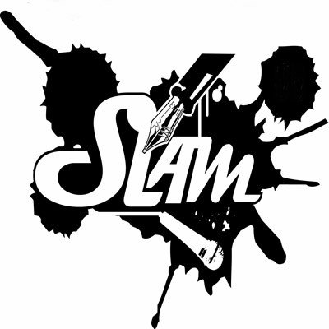
Slam poetry is not your grandmother’s poetry. It is about emotion, about force, about having something to say. As a class we will be researching the slam poetry movement and the poetic devices utilized in slam poetry. We will be doing this in preparation of having our own poetry slam. This is your opportunity to actually say something and have it be heard.

Day 1: Research information on slam poetry (also known as spoken word poetry) and present what you have found at the end of class.

Day 2-3: Create an open-ended question which more specifically explores what you would like to find out about slam poetry and write a MLA Formatted 350 word paper which presents your findings. ?” Do additional research to support your findings.

Examples of open-ended questions:
“Why did slam poetry begin as an art form?”
“Why do people perform slam poetry?”
“How similar or different is slam poetry to rap music?”

Day4: Bring finished papers to class. We will have a round-circle discussion on what you have learned from this experience and share our findings to our questions.

Day 5: Reflection activity and eventual class brainstorm on slam poetry topic ideas.

Remember: You should use MLA citations and have a works cited page at the end of your papers. These should be properly formatted.

Slam Poetry Performance

Mrs. Hirzel 2013
75 Points

Real poems are personal. Without that conviction, many poems fall flat. So, this is where you actually make a poem that means something to you. This is your opportunity to express frustration, love, injustice, joy, and passion. You will be writing and performing one poem that expresses human emotion and experience.

Components:
- A typed version of your poem: Literary devices should be underlined and labeled.
- A 1-2 page reflection paper on the figurative meaning of your poem (MLA FORMATTED)
- A 2+ Minute performance of your poem during our Class Poetry Slam

Your poem MUST include the following poetic devices creatively and interestingly to receive full credit:
- Simile or metaphor
- Alliteration
- Assonance or Consonance
- Hyperbole
- Personification or Allusion
- Repetition or Parallelism
- Imagery

Note: The most successful poems will not just use these literary devices once. They will use them THROUGHOUT the poem.
Due: Wednesday January 9, 2013
Poetry Slam Rubric
Mrs. Hirzel 2011-2012

Performance: (25 points)
Voice: The poet speaks clearly. The poet projects his/her voice, and effectively performs to the audience
5 4 3 2 1 0
Emotion: The poet conveys energy and emotion that is consistent with and enhances the ideas and mood of the poem.
5 4 3 2 1 0
Movement: The poet’s body movement, facial expressions, and gestures are consistent with and enhance the ideas and mood of the poem.
5 4 3 2 1 0
Preparation: Obvious preparation and practice is evident in performance.
5 4 3 2 1 0
Time: Does not go under 2 Minutes. Every 15 seconds under will be a point off.
5 4 3 2 1 0
Poem (50 points)
Poetic Devices: The poem is well crafted and demonstrates effective use of poetic devices.
(1) Simile or metaphor 5 4 3 2 1 0
(2) Alliteration 5 4 3 2 1 0
(3) Assonance or Consonance 5 4 3 2 1 0
(4) Hyperbole 5 4 3 2 1 0
(5) Personification or Allusion 5 4 3 2 1 0
(6) Repetition or Parallelism 5 4 3 2 1 0
(7) Imagery 5 4 3 2 1 0
Clarity: The poem clearly conveys an idea and a point of view of an appropriate subject.
5 4 3 2 1 0
Figurative Meaning Analysis: Response paper is thoughtful and discusses how the poem captures and conveys human emotion and experience.
10 9 8 7 6 5 4 3 2 1

